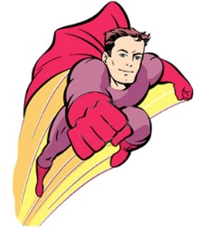
Design your own Superhero Road Safety Officer
What would they tell you about getting to school safely?
What special powers might they have?
What is their name?

